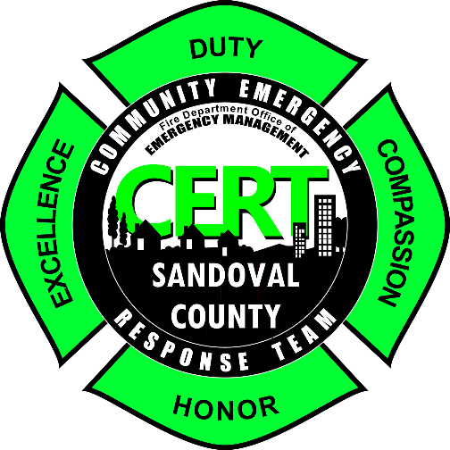

COMMUNITY EMERGENCY RESPONSE TEAM (CERT) PROGRAM HOLD HARMLESS/PERMISSION REQUEST

I, , hereby request permission to participate in the Sandoval County Community Emergency Response Team (CERT) program.

I understand that this training will involve active physical participation, which includes a potential risk of personal injury and/or personal property damage. I make this request with full knowledge of the possibility of personal injury and/or personal property damage. Further, I have read and understand the program outline that describes all class sections and the associated activities.

I agree to hold Sandoval County and their agents and personnel harmless from any and all claims, actions or suits for any injury that I may suffer and which may arise as a result of my participation in the CERT program training.

I agree to follow the rules established by the instructors, and to exercise reasonable care while participating in the CERT program. I understand that if I fail to follow the instructor's rules and regulations or if I fail to exercise reasonable care, I can be administratively removed from the program.

By executing this release, I certify that I have read this release in its entirety, understand all of its terms and have had any questions regarding the release or its effect satisfactorily answered. I sign this release freely and voluntarily.

Signature Date

Instructor Signature Date

